**ICT FINAL PROJECT**

**TECHNICAL REPORT**

**GROUP NAME:**

SHINING STARS

**GROUP MEMBERS:**

Muhammad Arqam Aleem

Muhammad Ahmed

Muhammad Awais

Rovaid Bashir

Ayezad Mirza

**OUR AIM:**

Is to make a website for a painting company which provides paints and painters for homes. We will add services and details about our company so clients can get aware about us. Our contact numbers and related information will be added so our clients can place their orders conveniently by having a look to our products displayed on website. We will also add our location and social handles for our clients so they can feel free to contact where ever they want.

**LOGO:**

 Logo is planned with keeping in view the essential point of organization which is to give paints and painters to homes.

**FLYER:**

Flyer is planned with extraordinary exertion alongside expansion of some organization's data and a best arrangement offered by the organization and administrations which organization gives.

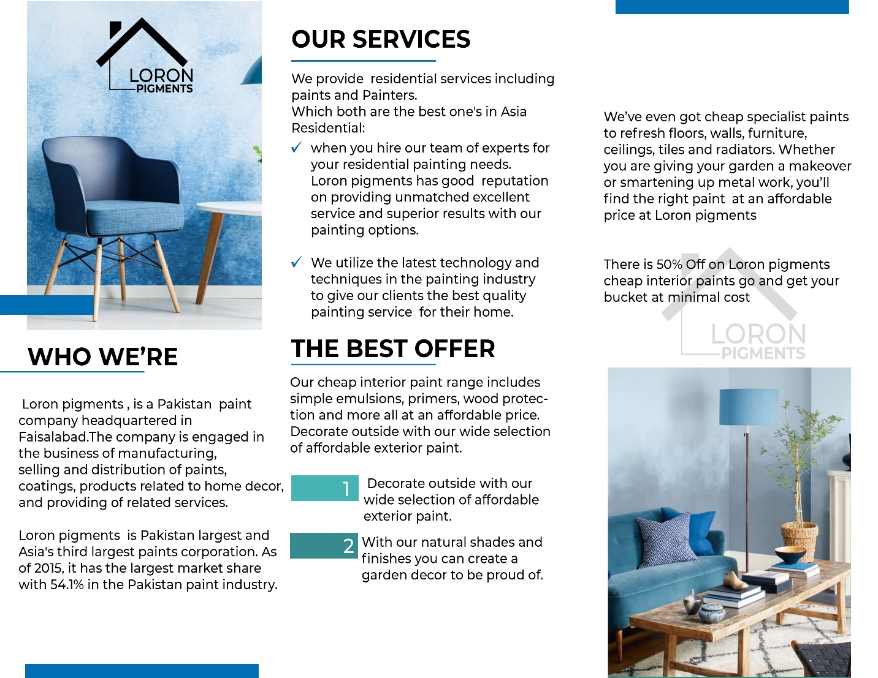

**HOME PAGE:**

Home page is consisting of buttons to shift pages along with the logo and a cinematic shot video on background.

**About Us:**

In about us we have examined about our organization and its status alongside the conversation of its aims and perspectives.

**PRODUCTS:**

We have displayed some of our products along with their reference codes imprinted on it so customers can place order easily by contacting with us through email or contact number provided on website.

**SERVICES:**

In administrations we have demonstrated what we are planning to give to our customers. We have indicated how our groups guarantee the extraordinary and up to check work with least costs when contrasted with different organizations.

We have told about our high level strategies for completing the work.

Alongside the quality we have amount too which is likewise talked about in a similar area.

**BLOGS/PAGES:**

In this segment we have added a portion of our web-based media connections and pages so our customers can visit them by basically tapping on the separate symbols of those locales.

**CONTACT:**

In this part we have shared our contact number and email with our customers to settle on them decision for putting requests to fill their homes with colors.

**FEEDBACK:**

We have added a feedback segment so we can get our client surveys about our administrations and items which we use to improve the norms of our organization and are the essential final proposal of our prosperity. We profoundly acknowledge and honor our client audits. Customer simply has to enter his name, email, contact number, and write his/her reviews in a section given and submit it.